1.Using vi write your CV in the file mycv. Your CV should include your name, age, school, college, experience,...



After press **i**

2. Open mycv file using vi command then: Without using arrows state how to:

Cursor hides when I try to take screenshot

a. Move the cursor down one line at time.

**Ecs>> J OR Enter**

b. Move the cursor up one line at time.

**Ecs>> k**

c. Search for word age

d. Step to line 5 (assuming that you are in line 1 and file is more than 5 lines).

e. Delete the line you are on and line 5.

Aftar **dd**

f. How to step to the end of line and change to writing mode in one-step.

**A** i add abdalftah at the end of line 1

3. List the available shells in your system.

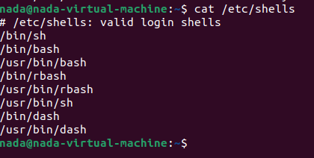

4. List the environment variables in your current shell.

5. List all of the environment variables for the bash shell. >>> man bash

6. What are the commands that list the value of a specific variable?

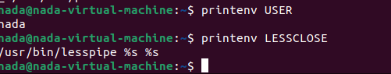

7. Display your current shell name.



9. Edit in your profile to display date at login





change your prompt permanently.



10. Execute the following command :

echo \ then press enter

What is the purpose of \ ?

* Second prompt

Notice the prompt ”>” what is that?

* Complete on my command

and how can you change it from “>” to “:”.

11. Create a Bash shell alias named ls for the “ls –l” command

